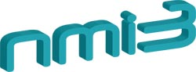

Deliverable Number:
Deliverable Title:

Delivery date:
Leading beneficiary:
Dissemination level: Public
Status: Version (number or final)
Authors:

Project number: 226507
Project acronym: NMI3
Project title: Integrated Infrastructure Initiative for Neutron Scattering and Muon Spectroscopy
Starting date: 1st of February 2009
Duration: 48 months
Call identifier: FP7-Infrastructures-2008-1
Funding scheme: Combination of CP & CSA – Integrating Activities

Abstract

Acknowledgements

Document History
Version | Modification | Date | Author(s)

Contents
Abstract 2
Acknowledgements 2
Document History 2

