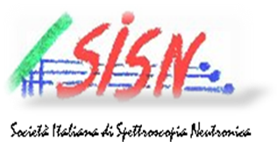

Application form - SISN Learning Days 2014

Introduction to neutron techniques for condensed matter studies, with applications to Physics, Chemistry, Biology and Earth sciences
13-22 September 2014

Name: Surname:

Position (degree/specializing/PhD student, post-doc, researcher, other):

Affiliation (University or Research Institut):

Address:

Phone:

e-mail:

Field of activity (please specify the field and/or the subject of thesis/research or the specialization field):

----------------------------------------------------------------------------------------------------------------

Asks for a grant for a partial coverage of stay and meals expenses:

YES ◻ NO ◻

Please note that, even if asking a grant, travel expenses towards Valle Aurina and backwards from Grenoble, as well as the costs of 3 days' stays and meals in Valle Aurina (about 125 euros in total) are in charge of the participant.

To be sent by e-mail within 30 April 2014 to the Direction of the SISN Learning Days:
Eleonora Guarini, Dip. Fisica e Astronomia Univ. Firenze and ILL Grenoble (guarini@fi.infn.it)

